Linux Lab #3

Ifconfig

ping -c 4 192.168.1.2

ps -ef

sudo apt-get install cowsay

sudo apt-get purge cowsay

cat food.txt

cat food.txt > newfile1.txt then cat newfile1.txt

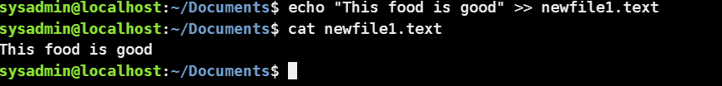

echo "This food is good." >> newfile1.txt then cat newfile1.txt

vi newfile1.txt (Screenshot)

write a few sentences in newfile1 using vi commands and save the file

after you save the file screenshot the contents of the newfile1.txt